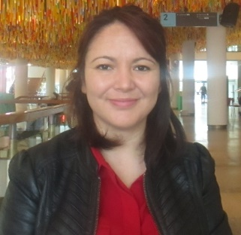**DIDEM BUHARI**

Didem Buhari is Professor of International Relations at Izmir Katip Celebi University, Turkey. She holds PhD in Politics and International Relations from the University of London (Royal Holloway College), MSc (by Research) from the University of Edinburgh and BSc from the Middle East Technical University. She worked as a postdoctoral fellow at Oxford Brookes University (2013-2014) and LSE European Institute/South East Europe section (2014-2015). She taught at several Universities in London, Oxford, Istanbul, and Izmir. She acted as a Jean Monnet Chair holder in 2017 at Istanbul Kemerburgaz University. She served as a researcher in the “Worldviews on the United States” (2018-2020) project sponsored by Japan Sasakawa Peace Foundation. She won a 2019 ISA workshop grant for her joint project (with B. Gulmez and B. Axford) on postwestern IR.

She is the author of the book “Europeanization in a Global Context: Integrating Turkey into the World Polity” (Palgrave 2017), and co-edited two special issues on Europe: “Europe and World Society” (2015, with Chris Rumford) for the *Journal of Contemporary European Studies* and the “Transforming Europe through crises: thin, thick, parochial and global dynamics” (2020, with Christian Kaunert and B. Gulmez) for *European Politics and Society*. She also co-edited three books: “Global Culture: Consciousness and Connectivity” (Routledge, 2016, with Roland Robertson), “Rethinking Ideology in the Age of Global Discontent” (Routledge, 2018, with Barrie Axford and B. Gulmez), and “Crisis and Change in Post-Cold War International Relations” (Palgrave, 2018, with Dovile Budryte and Erica Resende).

Her articles appeared in various indexed academic journals, including Contemporary Politics, International Political Sociology, Globalizations, New Global Studies, Journal of Contemporary European Studies, Comparative European Politics, Global Affairs, among others. Her research interests include sociological approaches to Europe, Globalization theories, postwestern IR, Transatlantic Relations, and national self-determination. She previously served on the Editorial board of the Journal of Critical Globalisation Studies (renamed as Finance and Society) and as an Associate Editor of “Global Affairs”, an EISA journal.